University Network Design Using Cisco Packet Tracer

A PROJECT REPORT
Submitted by:
NAME | ID
Md. Aminur Rhman | 18191203013
Md. Thoufique Hasan Rakib | 18191203012
Prottay Kumar Biswas | 18191203018

In Practical fulfillment of the requirement for the degree of

BACHELOR OF SCIENCE
IN
COMPUTER SCIENCE AND ENGINEERING



DEPARTMENT OF COMPUTER SCIENCE AND ENGINEERING
BANGLADESH UNIVERSITY OF BUSINESS AND TECHNOLOGY
MIRPUR-2, DHAKA-1216
DECEMBER-2022

DECLARATION

We do here by declare that the research works presented in this thesis entitled “University Network Design Using Cisco Packet Tracer '' are the results of our own works. We further declare that the thesis has been compiled and written by us. No part of this thesis has been submitted elsewhere for the requirement of so many degrees, award or diploma, or any other purpose except for publications. The materials that are obtained from other sources are duly acknowledged in this thesis.

Md.Aminur Rhman
ID:18191203013 _______________________
Signature

Md.Toufique Hasan Rakib
ID:18191203012 _______________________
Signature

Prottay Kumar Biswas
ID:18191203018 _______________________
Signature

APPROVAL

This project “University Network Design Using Cisco Packet Tracer ” Submitted by Md.Aminur Rhman, Md.Thoufique Hasan Rakib And Prottay Kumar Biswas ID NO:18191203013, 18191203012 and 18191203018.Department of Computer Science and Engineering (CSE), Bangladesh University Of Business and Technology (BUBT) under the supervision of Md.Saifur Rahman, Chairman , Department of Computer Science and Engineering has been accepted as satisfactory for the partial fulfillment of the requirement for the degree of Bachelor of Science (B.Sc. in Engineering) in Computer Science and Engineering and approved as to its style and contents.

…………………………………………………………
Md.Saifur Rahman
Assistant Professor and Chairman
Department of Computer Science and Engineering
Bangladesh University Of Business and Technology
(BUBT)
Mirpur -2,Dhaka-1216,Bangladesh

ACKNOWLEDGEMENT

Praise to Allah S.W.T The Most Gracious, whose blessing me through the process of completing this final year project. Peace be upon our prophet Muhmmad S.A.W, who has given light to mankind.

In particular, we wish to express my sincere appreciation and gratitude to my final year project supervisor, Md. Saifur Rahman for the knowledge, encouragement, guidance, critics and for all contributions towards my understanding and thoughts.

We sincerely thank all my friends for their support and helping directly and indirectly.

(Md.Aminur Rhman)

(Md.Thoufique Hasan Rakib)

(Prottay Kumar Biswas)

ABSTRACT

This paper describes the applications of simulation to enhance the understanding of networking communication, especially in routing and switching. The network topology, supporting CCNA (Cisco Certification Networking Academy) syllabus, will be developed and simulated using Cisco Packet Tracer software. Since the routing simulation using a real router and switch is very expensive, this project will give some advantages in terms of cost saving as the setup for the real network configuration is not required.

The project will focus more on the routing simulation and router configuration with Frame-Relay, DHCP, VLAN, Telnet, OSPF, HSRP. The outcome will provide a better understanding in the routing process, configure inter-VLAN routing on a router to enable communications between end-users’ devices on separate VLANs control access to an internal or external PC and DHCP is useful for automatic configuration of host. Cisco Packet Tracer software simulator along with VMware (Virtual Machine Software) Will be used in this project to simulate the routing topology.

TABLE OF CONTENTS

CONTENTS | PAGE NO
DECLARATION | 2
APPROVAL | 3
ACKNOWLEDGEMENT | 4
ABSTRACT | 5
Chapter 1: INTRODUCTION | 11-13
1.1 Introduction to Networking | 11
1.2 Purpose | 11
1.3 Objectives | 12
1.4 Expected Result | 12
1.5 Scope | 13
1.6 Significance of Study | 13
1.7 Significance of Packet Tracer | 13
Chapter 2: NETWORKING FUNDAMENTAL | 14-27
2.1 Introduction | 14
2.2 Computer Network | 14
2.2.1 Network models | 15
2.2.2 Network Topology | 16
2.2.3 Network Topology | 19
2.2.4 Layering Concept | 21
2.3 Switching | 23
2.4 Routing Protocols | 24
Chapter 3: BACKGROUND STUDY | 28-40
3.1 Frame-Relay | 28
3.2 DHCP | 28
3.2.1 Benefits of DHCP | 28
3.3 VLAN | 30
3.3.1 Advantages of VLANs | 30
3.4 Telnet | 33
3.5 Routing Interface Protocol (RIP) | 34
3.6 Open Shortest Path First (OSPF) | 36
3.7 Hot Standby Router Protocol (HSRP) | 38
3.8 Switch Name Change | 40
Chapter 4: METHODOLOGY | 41-42
4.1 Introduction | 41
4.2 Methodology | 41
4.3 Packet Tracer Network Simulator | 41
4.4 Creating a Topology in Packet Tracer | 41
Chapter 5: NETWORK DESIGN | 43-76
5.1 Introduction | 43
5.2 Scenario of Study | 43
Chapter 6: CONCLUSION | 77-79
6.1 Introduction | 77
6.2 Conclusion | 77
6.3 Recommendation | 78
BIBLIOGRAPHY | 79

TABLE OF FIGURES

FIGURE NAME | PAGE NO.
Fig 2.1: Computer Network | 14
Fig 2.2: Peer-to-Peer Network | 15
Fig 2.3: Server-based network | 15
Fig 2.4: Hybrid network | 16
Fig 2.5: Bus topology | 17
Fig 2.6: Ring Topology | 17
Fig 2.7: Star Topology | 18
Fig 2.8: Tree Topology | 18
Fig 2.9: Mesh Topology | 19
Fig 2.10: Station | 20
Fig 2.11: Transmission Media | 20
Fig 2.12: Connecting Devices | 21
Fig 2.13: OSI Model | 22
Fig 2.14: TCP/IP Model | 22
Fig 2.15: Switching Process | 23
Fig 2.16: Routing | 24
Fig 3.1: DHCP Configuration | 29
Fig 3.2: Vlan | 31
Fig 3.3: Telnet | 33
Fig 3.4: RIP Configuration | 34
Fig 3.5: OSPF Configuration | 36
Fig 3.6: HSRP Design | 38
Fig 3.7: HSRP Result | 38
Fig 3.8: Switch name Change | 40
Fig 4.1: Packet Tracer Overview | 42
Fig 5.1: Network Design | 43
Fig 5.2: Core Layer | 44
Fig 5.3: Distribution Layer | 45
Fig 5.4: Building 1 Configuration | 67
Fig 5.5: Building 2 Configuration | 68
Fig 5.6: Building 3 Configuration | 70
Fig 5.7: Building 4 Configuration | 72
Fig 5.8: Building 5 Configuration | 74
Fig 5.9: Building 6 Configuration | 75

CHAPTER 1
INTRODUCTION

1.1 Introduction to Networking

Routing and switching are an important process in networking systems and telecommunication. Basic function of routing is to make sure that the routers and switches can communicate with each other and to perform data transfer from source to destination. Since routing is very important in network communication, it is necessary to know the routing process in networking.

Routing and switching processes can be studied by performing simulation, whether using real routers is virtual router configuration. In real router configuration, obviously real routers are needed. For virtual router simulations, what is needed is reliable software that supports router configuration. Within this way, the art of routing and switching can be more understandable.

From the two choices, virtual router configuration is most likely suitable for the student because it gives better understanding in the routing process while saving the cost. In fact, the real router configuration will consume much cost since the real router is very expensive. Besides that, network simulation tools are usually supported with many types of routers, so it is possible to build several network topologies by using simulator software.

This simulation method is very familiar nowadays either for education purposes or industrial purposes. For educational purposes, the simulation is usually performed as lab work. In industry, usually some company specialized in networking used this method to predict the performance of a network that will be built or for maintenance and checking the current network performance.

1.2 Purpose

To enhance understanding in routing and switching in networking through the simulation using Cisco packet tracer simulation software. The main purpose of the project is to design the network design of a university.

1.3 Objectives

- Explain how network traffic routed between VLANs in a converged network. Configure Inter-VLAN routing on a router to enable communications between end-user devices on separate VLANs.

- Configure static IP mapping to allow outside access to an internal PC.

- Summarization reduces the amount of information stored in the routing table and makes the routing process more efficient.

- Dynamic Host Configuration Protocol (DHCP) is useful for automatic configuration of client network interfaces.

- Accessing internet services from organizations.

- Many universities in developing countries are searching for ways to integrate networks that have security, backup, and other features available in a university network in a developed country. The universities in developing countries are faced with challenges in designing a network that is equal in the standards used by developed countries.

- This project will help these universities to design a network that employs low-cost solutions without unacceptable compromises in security or quality.

1.4 Expected Result

We have divided our project into 3 parts.
- Core Layer
- Distribution Layer
- Access Layer

Core Layer: 2 lines from the ISP will connect to the core layer. There are 2 routers in this layer. We have done the Hot Standard Routing Protocol (HSRP) between these 2 routers (to physically make 2 routers into 1 router). And distribution layer 2 L3 switches and 2 routers of the core layer have done Open Shortest Path First (OSPF) together (OSPF is usually used to travel data through short paths).

Distribution Layer: There are 2 L3 switches connected in mesh topology with 2 core layer routers. Configuration HSRP + OSPF and DHCP configuration. Connection is made from our access layer to the server.

Access Layer: Connections are made to access layer switches. And each switch in the access layer is divided into building blocks.

1.5 Scope

The project is designed for infrastructure where it can be used on a small scale. This project is currently working on a small number of devices but may add more devices and connections in the future. The device consists of various computers, routers, servers, connections and switches built with proper efficiency. Devices and associated connections are limited due to funding concerns of medium or small universities.

Therefore, anyone can say that the scheme plays an undeniable role in cost containment in due course.

1.6 Significance of Study

The proposed study will contribute to a better understanding of Routing, Switching. OSPF, HSRP, Telnet and network model, network components process in networking. Suggestions and recommendations will be developed to simulate several router topologies. Hopefully, it is sufficient to provide more understanding in the routing process.

1.7 Significance of Packet Tracer

Cisco Packet Tracer is a network simulation program that allows students to experiment with network behavior and ask “what if” questions. As an integral part of the Networking Academy comprehensive learning experience, Packet Tracer provides simulation, visualization, authoring, assessment, and collaboration capabilities and facilities the teaching and learning of complex technology concepts.

CHAPTER 2
NETWORKING FUNDAMENTAL

2.1 Introduction

This chapter will consist of the basic terminology for the project. Merely it consists of the networking fundamental and routing basic knowledge. Since the project is more about routing and switching, it concerns more on those subjects.

2.2 Computer Network

Communication system has a main purpose, it is to exchange data between two parties; and a computer network is a number of computers interconnected by one or more transmission paths. A computer network allows computers to communicate with many other and share resources and information.

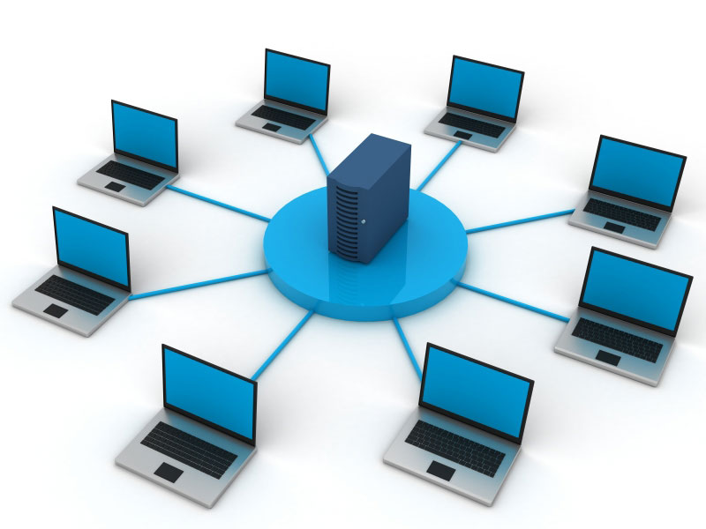

Fig 2.1: Computer Network

2.2.1 Network models

There are three types of networks based on its connection. They are Peer-to-Peer Networks, Server-Based Network, Hybrid Network. Descriptions of these networks are as follows.

Peer-to-Peer Network is a network that has no client and server. Each machine (Computer) can both send and receive data files and process data using those files. The advantage of this network is the simplicity in both design and maintenance.

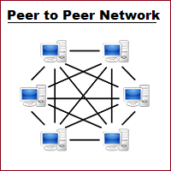
Fig 2.2: Peer-to-Peer Network

For a server-based network, it is the opposite of a peer-to-peer network. It is a network that has the client and server. Server is any machine that stores and sends out data along the network. In this system, the clients are usually computers on the network that are operated by human beings, making changes to be data files they received and, when those changes are complete, sending the files back to the file server for storage. This kind of network has good quality in processing efficiency, especially on large networks with dozens or even hundred machines.

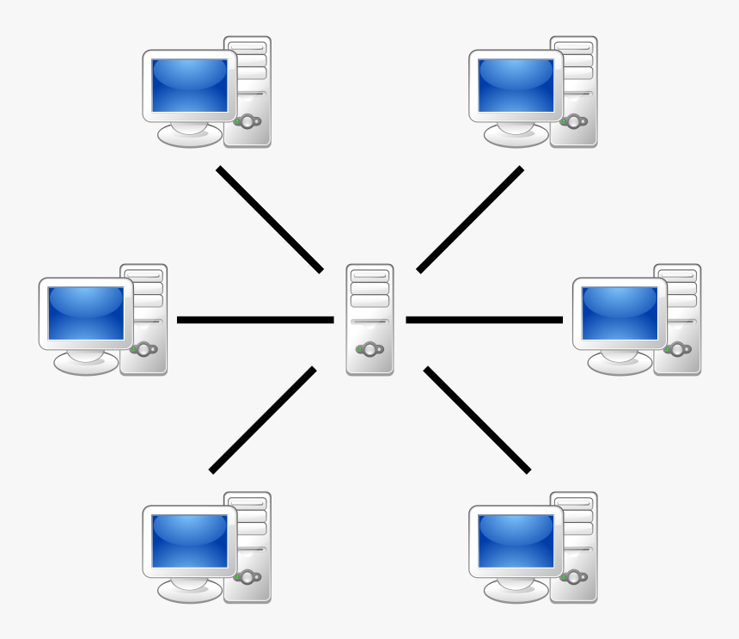
Fig 2.3: Server-based network
The last network is the hybrid network. It is a combination of any two or more topologies in such a way that the resulting network does not exhibit one of the standard topologies. Two common examples for hybrid networks are the star-ring network and the star-bus network. The network that will be performed in this simulation is peer-to-peer network, which has no server and clint.

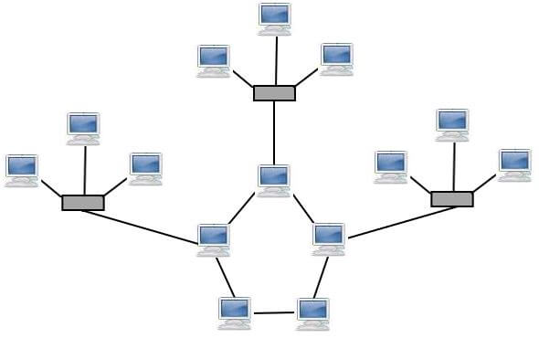

Fig 2.4: Hybrid network

‘

2.2.2 Network Topology

A network topology is the physical and logical arrangement of nodes and connections in a network. Nodes usually include devices such as switches, routers and software with switch and router features. Network topologies are often represented as a graph.

Network topologies describe the arrangement of networks and the relative location of traffic flows. Administrators can use network topology diagrams to determine the best placements for each node and the optimal path for traffic flow. With a well-defined and planned-out network topology, an organization can more easily locate faults and fix issues, improving its data transfer efficiency.

Network geometry can be defined as the physical topology and the logical topology. Network topology diagrams are shown with devices depicted as network nodes and the connections between them as lines. The type of network topology differs depending on how the network needs to be arranged.

Bus Topology

Bus topology uses a single cable which connects all the included nodes. The main cable acts as a spine for the entire network. One of the computers in the network acts as the computer server. When it has two endpoints, it is known as a linear bus topology.

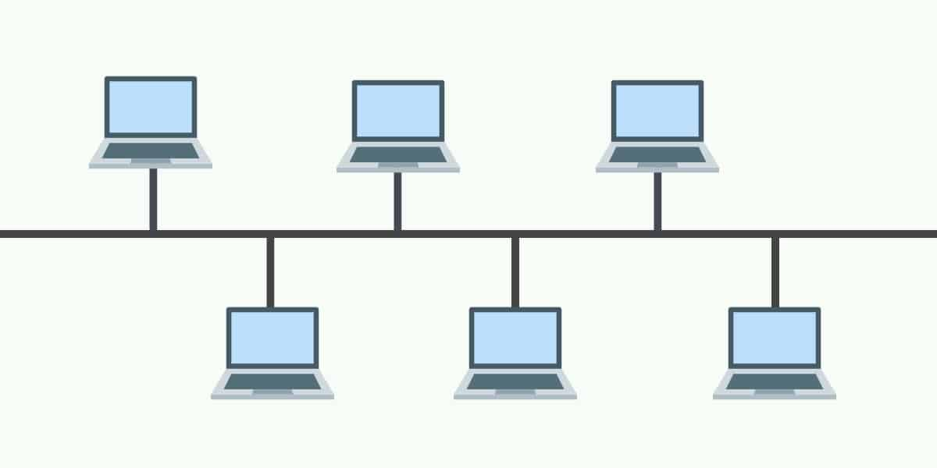
Fig 2.5: Bus topology

Ring Topology

In a ring network, every device has exactly two neighboring devices for communication purposes. It is called a ring topology as its formation is like a ring. In this topology, every computer is connected to another computer. Here, the last node is combined with the first one.

This topology uses a token to pass the information from one computer to another. In this topology, all the messages travel through a ring in the same direction.

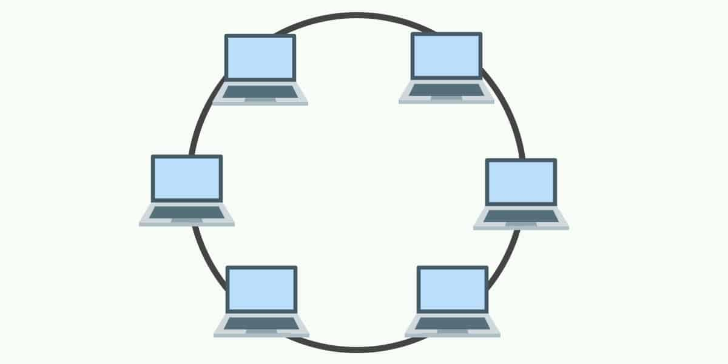
Fig 2.6: Ring Topology
Star Topology

In the star topology, all the computers connect with the help of a hub. This cable is called a central node, and all other nodes are connected using this central node. It is most popular on LAN networks as they are inexpensive and easy to install.

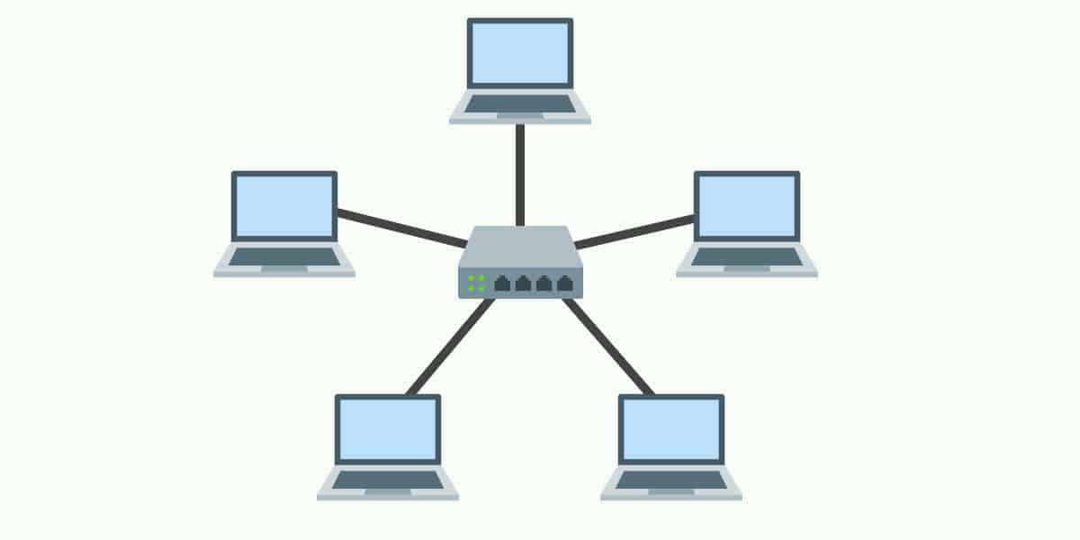

Fig 2.7: Star Topology

Tree Topology

Tree topologies have a root node, and all other nodes are connected which form a hierarchy. So, it is also known as hierarchical topology. This topology integrates various star topologies together in a single bus, so it is known as a Star Bus topology. Tree topology is a very common network which is similar to a bus and star topology.

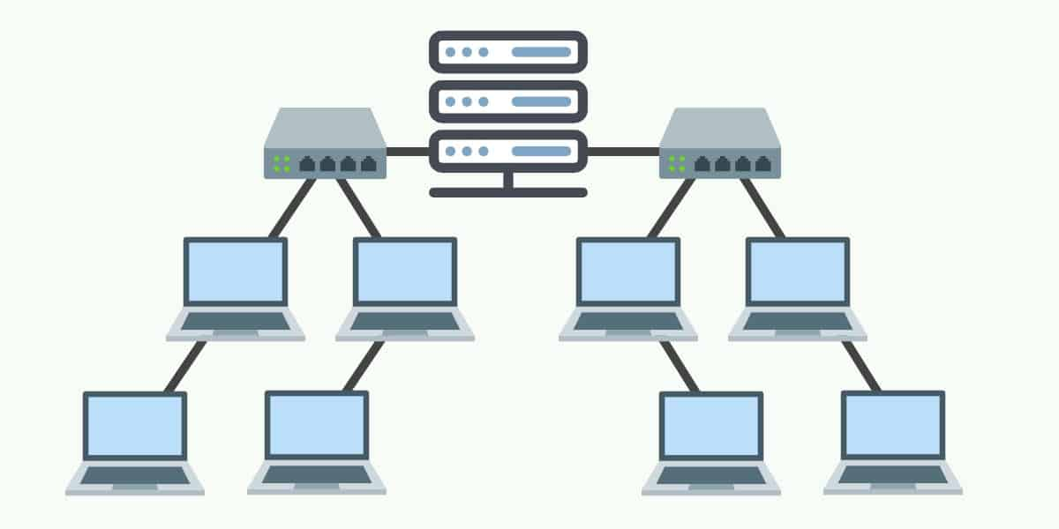
Fig 2.8: Tree Topology

Mesh Topology

A mesh topology is a point-to-point connection where nodes are interconnected. In this form of topology, data is transmitted via two methods: routing and flooding. Routing is where nodes use routing logic to work out the shortest distance to the packet’s destination. In contrast, flooding is where data is sent to all nodes within the network. Flooding doesn’t require any form of routing logic to work.

There are two forms of mesh topology: partial mesh topology and full mesh topology. With partial mesh topology, most nodes are interconnected but there are a few which are only connected to two or three other nodes. A full mesh topology is where every node is interconnected.

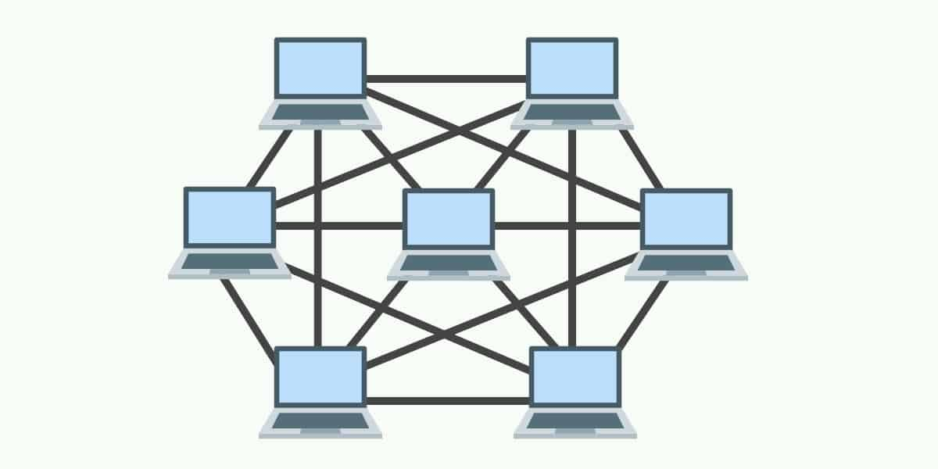

Fig 2.9: Mesh Topology

2.2.3 Network Component

A network is a combination of both hardware and software. The hardware is the parts that construct the network physically. Software is a collection of programs that is used to run the network.

Roughly, the hardware components that are used in network can be divided into three categories: stations, transmission media, and connecting devices.

A station sometimes is referred to as nodes. Examples of a station are computers, printers and modems. Each station must have capability to be connected to the network; a station needs extra hardware or software tools to perform networking tasks such as sending and receiving data and monitoring the network.
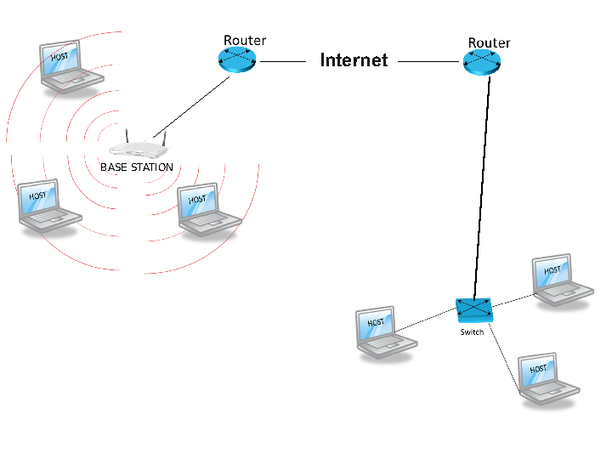
Fig 2.10: Station

Transmission media is the path that allows communication between stations. Nowadays, LANs use either guided (cable) or unguided (air and vacuum) transmission media.

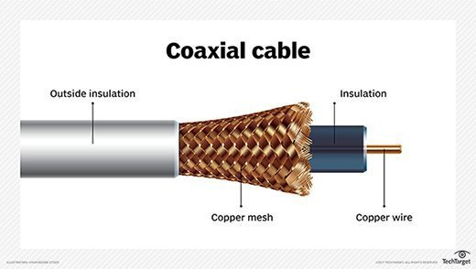
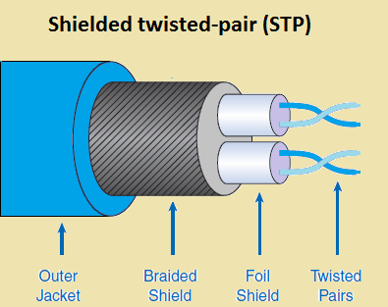
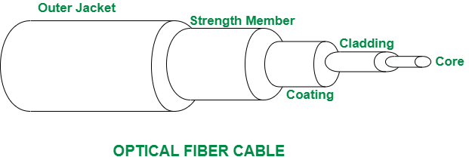

Fig 2.11: Transmission Media

In computer networks, especially in LAN, two categories of connecting devices are used. First category is the devices that connect transmission media to the stations; transceivers and transceiver cables. The second is the devices that connect segments of the network together; repeaters, bridges, routers, and switches. The main focus of this project will be on the router that connects stations.

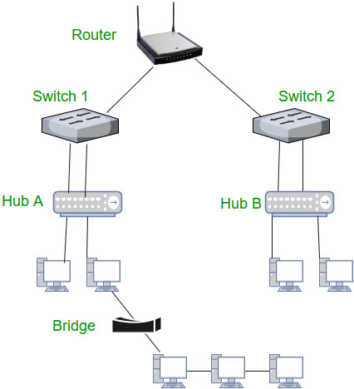

Fig 2.12: Connecting Devices

For software components, usually there are two large groups of software that are run on a LAN; they are NOS and application programs. NOS is a program that allows logical connection of stations and devices to the network, it is useful in enabling the users to communicate and share resources. As for application programs, it allows users to solve special problems.

2.2.4 Layering Concept

In a layered architecture approach, the complex task of communication between two applications is broken into smaller subtasks and each subtask is assigned to a layer. Shows two familiar layering architectures that have been used today, they are OSI model and TCP/IP model. OSI model is a layered framework for the design of network systems that allows for communication across all types of computer systems. It consists of seven layers that are separated but related, namely physical, data link, network, transport, presentation, session, and application layer. Each layer defines a part of the process in moving information across a network. The other model or protocol is the TCP/IP protocol. It was developed prior to the OSI model. That is why the layers in the TCP/IP protocol do not match exactly with those in the OSI model. The TCP/IP protocol is made of three layers: network, transport and application that sit on two layer protocols.

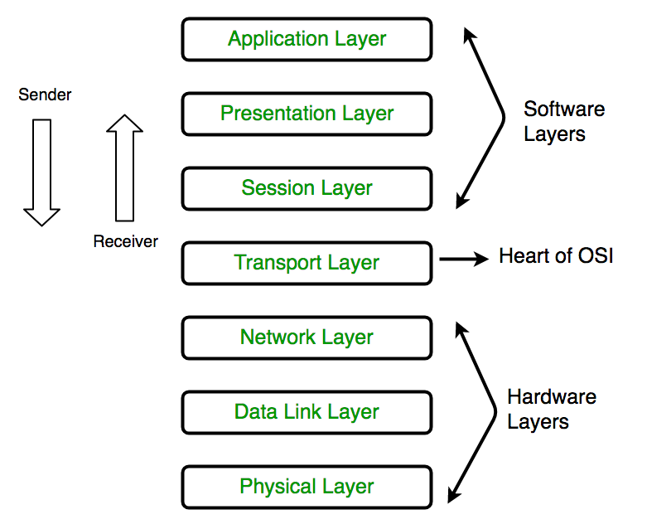
Fig 2.13 :OSI Model

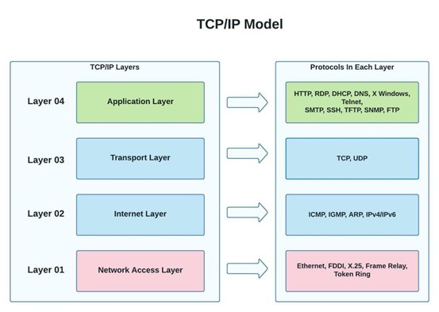
Fig 2.14 :TCP/IP Model

The network and transport layers provide internetworking and transport functions. The three topmost layers in the OSI model are represented by the application layer in a TCP/IP

2.3 Switching

Switches are one of the most numerous devices installed onto the corporate network infrastructure. Configuring them can be fun and challenging. Knowing how switches normally boot and load an operating system is also important.
Switching algorithms is relatively simple; it is the same for most routing protocols.

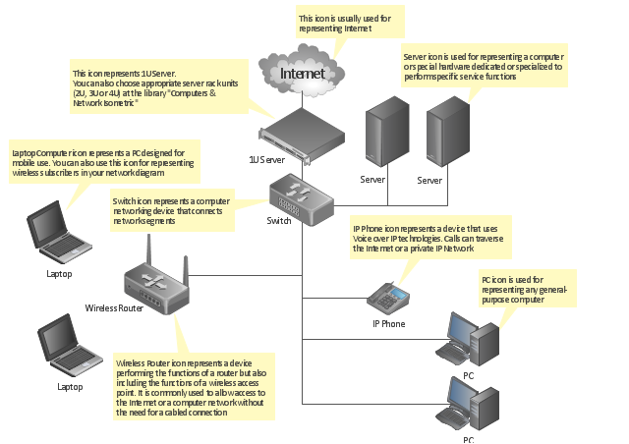
Fig 2.15: Switching Process

As for the switching process, there are several steps in it. First is determining where the data must be sent, in other words the address of the destination, both physical and protocol port addresses. After acquiring the packets with the address, the packet will be transferred to the router's physical address along with the protocol address of the destination host. When the data arrives at the router, it will determine whether the router knows or does not know how to forward the packet to the destination (next hop) by examining the destination 15 protocol address. If the router does not know, it will automatically drop the packet. If it knows, it will forward the packet after unchanging the destination physical address to the next hop. This process will be repeated until the packets arrive at the destination.

2.4 Routing Protocols

Routing is the act of moving information across an internetwork from a source to a destination. In the process, at least one intermediate node typically is encountered. Routing is often contrasted with bridging, which might seem to accomplish precisely the same thing to the casual observer. The primary difference between the two is that bridging occurs at Layer 2 (the link layer) of the OSI reference model, whereas routing occurs at Layer 3 (the network layer). This distinction provides routing and bridging with different information to use in the process of moving information from source to destination, so the two functions accomplish their tasks in different ways.

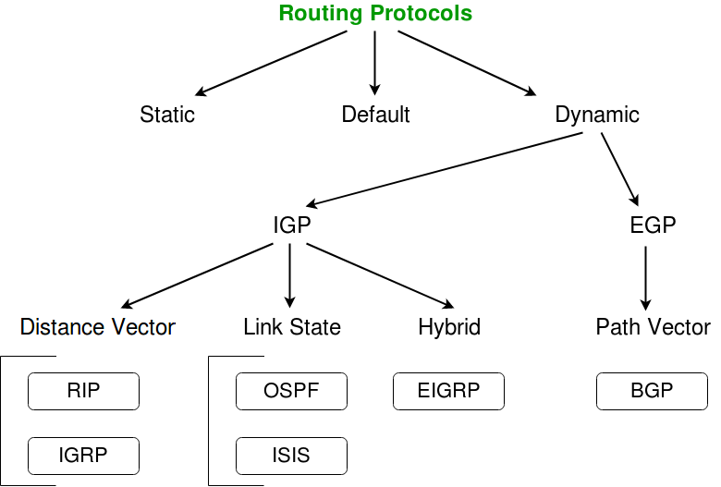

Fig 2.16: Routing

STATIC

Static routing protocols are used when an administrator manually assigns the path from source to the destination network. It offers more security to the network.

Advantages

- No overhead on the router CPU.
- No unused bandwidth between links.
- Only the administrator is able to add routes

Disadvantages

- The administrator must know how each router is connected.
- Not an ideal option for large networks as it is time intensive.
- Whenever link fails all the network goes down which is not feasible in small networks

DEFAULT

This is the method where all routers are configured to send all packets towards a single router. This is a very useful method for small networks or for networks with a single entry and exit point. It is usually used in addition to Static and/or Dynamic routing.

DYNAMIC

Dynamic routing protocols are another important type of routing protocol. It helps routers to add information to their routing tables from connected routers automatically. These types of protocols also send out topology updates whenever the network changes’ topological structure.

Advantage

- Easier to configure even on larger networks.
- It will dynamically be able to choose a different route in case a link goes down.
- It helps you to do load balancing between multiple links.
- Disadvantage:
- Updates are shared between routers, so it consumes bandwidth.
- Routing protocols put an additional load on router CPU or RAM.

Disadvantages

- Requires more heavy and reliable powerful hardware.
- Higher maintenance compared to static protocol

IGP

Interior Gateway Protocol (IGP) is a dynamic class routing protocol used by autonomous system routers running on TCP/IP hosts.
IGP overcomes Routing Information Protocol (RIP) network limitations and supports multiple routing metrics, including delay, bandwidth, load and reliability.

EGP

Exterior Gateway Protocol (EGP) is used to exchange net-reachability information between Internet gateways belonging to the same or different autonomous systems.

EGP was developed by Bolt, Beranek and Newman in the early 1980s. It was first described in RFC 827 and formally specified in RFC 904 (1984).

Distance Vector

Routers running distance vector algorithms advertise the vector (path) and distance (metric) for each destination reachable within the network to adjacent (directly connected) peers. This information is placed in a local database as it is received, and some algorithm is used to determine which path is the best path to each reachable destination. Once the best path is determined, these best paths are advertised to each directly connected adjacent router.

Two common algorithms used for determining the best path are Bellman-Ford, which is used by the Routing Information Protocol (RIP and RIPv2), and the Diffusing Update Algorithm (DUAL), used by the Enhanced Interior Gateway Protocol (EIGRP).

Link State

A complex routing protocol that shares information with other routers in order to determine the best path. IS-IS was the first comprehensive link state protocol, and OSPF and NLSP evolved from it. Link state protocols use characteristics of the route such as speed and cost as well as current congestion to determine the best path, which is typically computed by the Dijkstra algorithm.

Link state routers are updated from all the routers in the entire network by passing information from router to nearest router. Rather than continuously broadcast its routing tables as does a distance vector protocol, a link state protocol router only notifies its neighboring routers when it detects a change.

Hybrid

A complex routing protocol that shares information with other routers in order to determine the best path. IS-IS was the first comprehensive link state protocol, and OSPF and NLSP evolved from it. Link state protocols use characteristics of the route such as speed and cost as well as current congestion to determine the best path, which is typically computed by the Dijkstra algorithm.

Link state routers are updated from all the routers in the entire network by passing information from router to nearest router. Rather than continuously broadcast its routing tables as does a distance vector protocol, a link state protocol router only notifies its neighboring routers when it detects a change.

Path vector

Path vector (PV) protocols, such as BGP, are used across domains aka autonomous systems. In a path vector protocol, a router does not just receive the distance vector for a particular destination from its neighbor; instead, a node receives the distance as well as path information (aka BGP path attributes), that the node can use to calculate (via the BGP path selection process) how traffic is routed to the destination AS.
CHAPTER 3
BACKGROUND STUDY

3.1 Frame-Relay

Frame relay is a telecommunication service designed for cost-efficient data transmission for intermittent traffic between local area networks (LANS) and between end-points in a wide area network (WAN). Frame relay puts data in a variable-size unit called a frame and leaves any necessary error correction (retransmission of data) up to the end-points, which speeds up overall data transmission.

3.2 DHCP

Dynamic Host Configuration Protocol (DHCP) is a client/server protocol that automatically provides an Internet Protocol (IP) host with its IP address and other related configuration information such as the subnet mask and default gateway. RFCs 2131 and 2132 define DHCP as an Internet Engineering Task Force (IETF) standard based on Bootstrap Protocol (BOOTP), a protocol with which DHCP shares many implementation details. DHCP allows hosts to obtain required TCP/IP configuration information from a DHCP server.

3.2.1 Benefits of DHCP

The DHCP Server service provides the following benefits:
- Reliable IP address configuration.
- DHCP minimizes configuration errors caused by manual IP address configuration, such as typographical errors, or address conflicts caused by the assignment of an IP address to more than one computer at the same time.
- Reduced network administration.

DHCP includes the following features to reduce network administration:

- Centralized and automated TCP/IP configuration.
- The ability to define TCP/IP configurations from a central location.
- The ability to assign a full range of additional TCP/IP configuration values by means of DHCP options.
- The efficient handling of IP address changes for clients that must be updated frequently

DHCP Configuration:

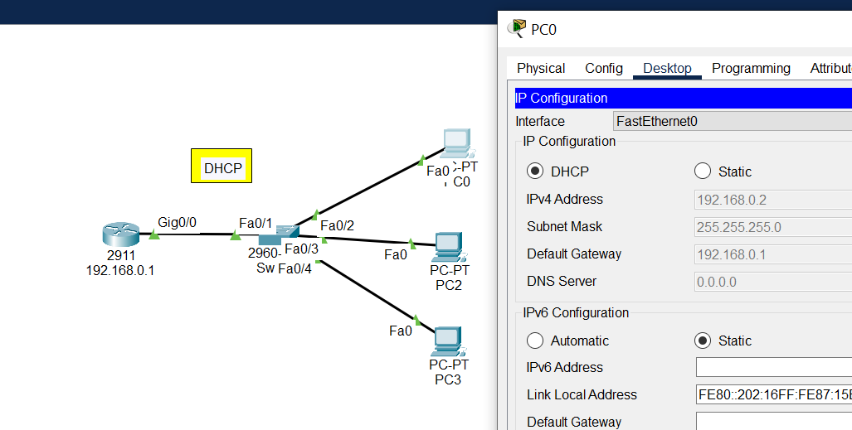

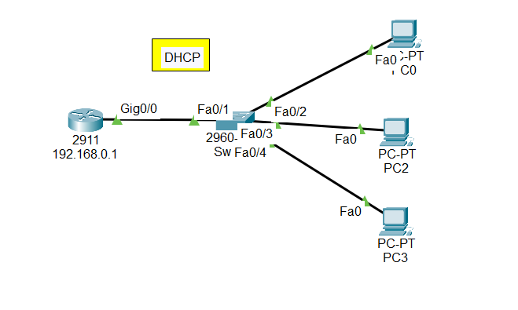
Fig 3.1:DHCP Configuration

CODE:

Router>
Router>en
Router#conf t
Router(config)#hostname BUBT_Router
BUBT_Router(config)#interface gigabitEthernet 0/0
BUBT_Router(config-if)#ip address 192.168.0.1 255.255.255.0
BUBT_Router(config-if)#no shut
BUBT_Router(config-if)#
BUBT_Router(config-if)#exit
BUBT_Router(config)#
BUBT_Router(config)#ip dhcp pool BUBT
BUBT_Router(dhcp-config)#network 192.168.0.0 255.255.255.0
BUBT_Router(dhcp-config)#default-router 192.168.0.1
BUBT_Router(dhcp-config)#exit
BUBT_Router(config)#exit
BUBT_Router#

3.3 VLAN

A virtual LAN (VLAN) is any broadcast domain that is partitioned and isolated in a computer network at the data link layer (OSI layer 2). LAN is an abbreviation of local area network. To subdivide a network into virtual LANs, one configures a network switch or router.

3.3.1 Advantages of VLANS

VLANS provide a number of advantages, such as ease of administration, confinement of broadcast domains, reduced broadcast traffic, and enforcement of security policies. VLANS provide the following advantages:

Stations that are physically dispersed on a network:

When users on a VLAN move to a new physical location but continue to perform the same job function, the end-stations of those users do not need to be reconfigured.
Similarly, if users change their job functions, they need not physically move: changing the VLAN membership of the end-stations to that of the new team makes the users! end-stations local to the resources of the new team.
Routers deployed on a network to contain broadcast traffic.
Flooding of a packet is limited to the switch ports that belong to a VLAN. significantly reduces traffic.
By confining the broadcast domains, end-stations on a VLAN are prevented from listening to or receiving broadcasts not intended for them. Moreover, if a router is not connected between the VLANS, the end-stations of a VLAN cannot communicate with the end-stations of the other VLANs.

VLAN configuration:

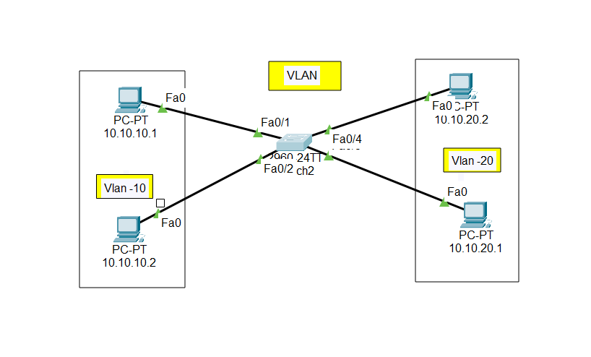
Fig 3.2:Vlan

CODE:

Switch :
Switch>
Switch>en
Switch#conf t
Switch(config)#
Switch(config)#vlan 10
Switch(config-vlan)#name cse
Switch(config-vlan)#vlan 20
Switch(config-vlan)#name eee
Switch(config-vlan)#ex
Switch(config)#
Switch(config)#
Switch(config)#
Switch(config)#do sh vlan

VLAN Name Status Ports
---- -------------------------------- --------- -------------------------------
1 default active Fa0/1, Fa0/2, Fa0/3, Fa0/4
Fa0/5, Fa0/6, Fa0/7, Fa0/8
Fa0/9, Fa0/10, Fa0/11, Fa0/12
Fa0/13, Fa0/14, Fa0/15, Fa0/16
Fa0/17, Fa0/18, Fa0/19, Fa0/20
Fa0/21, Fa0/22, Fa0/23, Fa0/24
Gig0/1, Gig0/2
10 cse active
20 eee active
1002 fddi-default active
1003 token-ring-default active
1004 fddinet-default active
1005 trnet-default active

------------------------------------------------------------------------------
Switch(config)#
Switch(config)#int fastEthernet 0/1
Switch(config-if)#switchport mode access
Switch(config-if)#switchport access vlan 10
Switch(config-if)#ex
Switch(config)#int fastEthernet 0/2
Switch(config-if)#sw mode access
Switch(config-if)#switchport access vlan 10
Switch(config-if)#ex
Switch(config)#
Switch(config)#int fastEthernet 0/3
Switch(config-if)#sw mode access
Switch(config-if)#switchport access vlan 20
Switch(config-if)#ex
Switch(config)#int fastEthernet 0/4
Switch(config-if)#sw mode access
Switch(config-if)#switchport access vlan 20
Switch(config-if)#ex
Switch(config)#do sh vlan br

VLAN Name Status Ports
---- -------------------------------- --------- -------------------------------
1 default active Fa0/5, Fa0/6, Fa0/7, Fa0/8
Fa0/9, Fa0/10, Fa0/11, Fa0/12
Fa0/13, Fa0/14, Fa0/15, Fa0/16
Fa0/17, Fa0/18, Fa0/19, Fa0/20
Fa0/21, Fa0/22, Fa0/23, Fa0/24
Gig0/1, Gig0/2
10 cse active Fa0/1, Fa0/2
20 eee active Fa0/3, Fa0/4
1002 fddi-default active
1003 token-ring-default active
1004 fddinet-default active
1005 trnet-default active
Switch(config)#
Switch#

3.4 Telnet

Telnet is a user command and an underlying TCP/IP protocol for accessing remote computers. Through Telnet, an administrator or another user can access someone else's computer remotely.

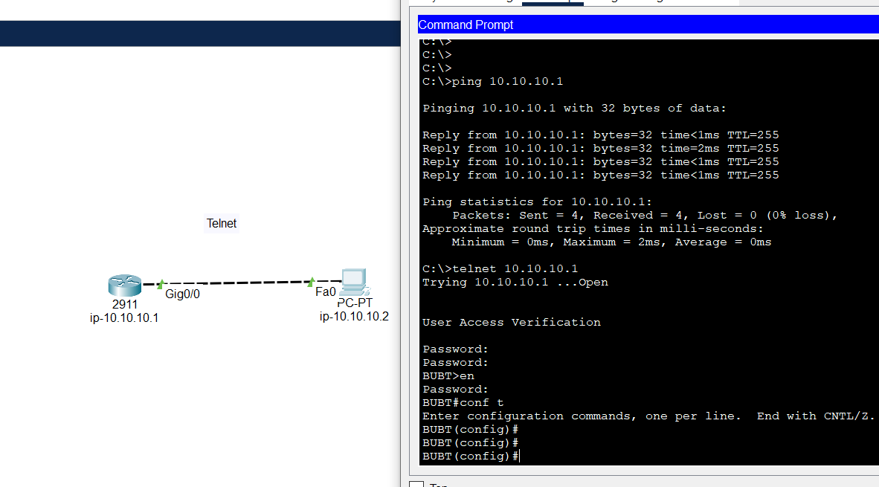
Fig 3.3:Telnet

CODE:

Router>en
Router#conf t
Router(config)#hostname BUBT
BUBT(config)#int gigabitEthernet 0/0
BUBT(config-if)#no shutdown
BUBT(config-if)#ip address 10.10.10.1 255.255.255.0
BUBT(config-if)#ex
BUBT(config)#
BUBT(config)#line vty 0 15
BUBT(config-line)#password cisco
BUBT(config-line)#login
BUBT(config-line)#exit
BUBT(config)#
BUBT(config)#enable secret cisco123
BUBT(config)#
BUBT(config)#ex
BUBT#

3.5 Routing Interface Protocol (RIP)

Routing Information Protocol (RIP) is a standards-based, distance-vector, interior gateway protocol (IGP) used by routers to exchange routing information. RIP uses hop count to determine the best path between two locations. Hop count is the number of routers the packet must go through till it reaches the destination network. The maximum allowable number of hops a packet can traverse in an IP network implementing RIP is 15 hops.

RIP Configuration:

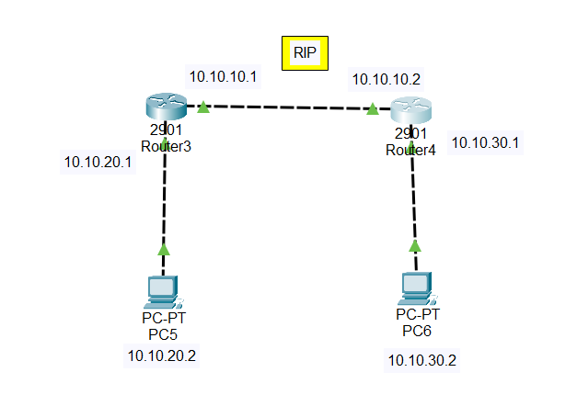
Fig 3.4: RIP Configuration

CODE:

Router1:

Router>
Router>EN
Router#CONF T
Router(config)#int
Router(config)#interface gigabitEthernet 0/1
Router(config-if)#ip address 10.10.20.1 255.255.255.0
Router(config-if)#no shut
Router(config-if)#ex
Router(config)#int gig 0/0
Router(config-if)#ip address 10.10.10.1 255.255.255.0
Router(config-if)#no shut
Router(config-if)#exit
Router(config)#router rip
Router(config-router)#version 2
Router(config-router)#network 10.10.10.0
Router(config-router)#network 10.10.20.0
Router(config-router)#exit
Router#

Router2:

Router>
Router>en
Router#conf t
Router(config)#
Router(config)#int
Router(config)#interface gigabitEthernet 0/1
Router(config-if)#ip address 10.10.30.1 255.255.255.0
Router(config-if)#no shut
Router(config)#
Router(config)#int gig 0/0
Router(config-if)#ip address 10.10.10.2 255.255.255.0
Router(config-if)#no shut
Router(config-if)#ex
Router(config)#router rip
Router(config-router)#version 2
Router(config-router)#network 10.10.10.0
Router(config-router)#network 10.10.30.0
Router(config-router)#ex
Router(config)#
Router#

3.6 Open Shortest Path First (OSPF)

OSPF is a routing protocol that is used to allow routers to dynamically learned routes from other routers and to advertise routes to other routers. Advertisements containing routes are referred to as LSAS in OSPF. OSPF router keeps track of the state of all various network connections (links) between itself and a network it is trying to send data to. It uses areas to organize networks into a hierarchical structure. That is why OSPF requires routers that have more powerful processors and more memory than the other routing protocol.

In OSPF, all router interfaces (links) are given a cost. The cost of a route is equal to the sum of all the costs configured on all the outbound links between the router and the destination network, plus the cost configured on the interface that OSPF received Link State Advertisement on. Then, OSPF will select the best routes to destination by finding the lowest cost paths to a destination.

OSPF Configuring:

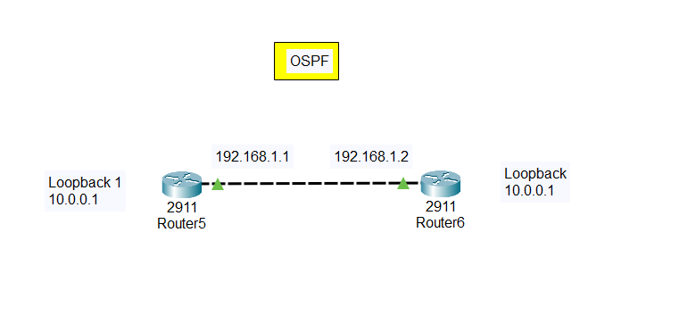

Fig 3.5: OSPF Configuration

CODE:

Router1:

Router>
Router>en
Router#conf t
Router(config)#interface gigabitEthernet 0/0
Router(config-if)#ip address 192.168.1.1 255.255.255.0
Router(config-if)#no shut

Router(config-if)#
Router(config)#interface loopback 1
Router(config-if)#
Router(config-if)#ip address 10.0.0.1 255.0.0.0
Router(config-if)#ex
Router(config)#router ospf 1
Router(config-router)#network 10.0.0.0 255.255.255.255are
Router(config-router)#network 10.0.0.0 255.255.255.255 area 0
Router(config-router)#network 192.16.1.0 0.0.0.255 area 0
Router(config-router)#ex
Router(config)#ex
Router#

Router 2:

Router>en
Router#conf t
Router(config)#int gig 0/0
Router(config-if)#ip address 192.168.1.2 255.255.255.0
Router(config-if)#no shut
Router(config-if)#
Router(config-if)#ex
Router(config)#inter
Router(config)#interface loo
Router(config)#interface loopback 1
Router(config-if)#
Router(config-if)#ip address 20.0.0.1 255.0.0.0
Router(config-if)#ex
Router(config)#ex
Router(config)#router ospf 1
Router(config-router)#net
Router(config-router)#network 20.0.0.0 255.255.255.0 area 0
Router(config-router)#net
Router(config-router)#network 192.168.1.0 0.0.0.255 area 0
Router(config-router)#ex
Router(config)#ex
Router#
Router#sh ip ospf nei

Neighbor ID Pri State Dead Time Address Interface
10.0.0.1 1 FULL/DR 00:00:36 192.168.1.1 GigabitEthernet0/0
Router#

3.7 Hot Standby Router Protocol (HSRP):

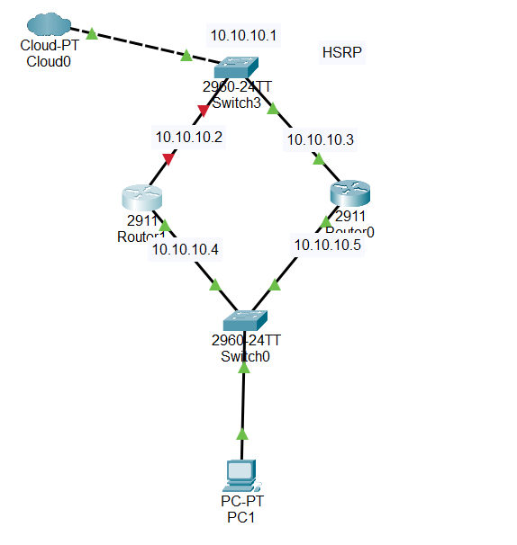
Fig 3.6 : HSRP Design

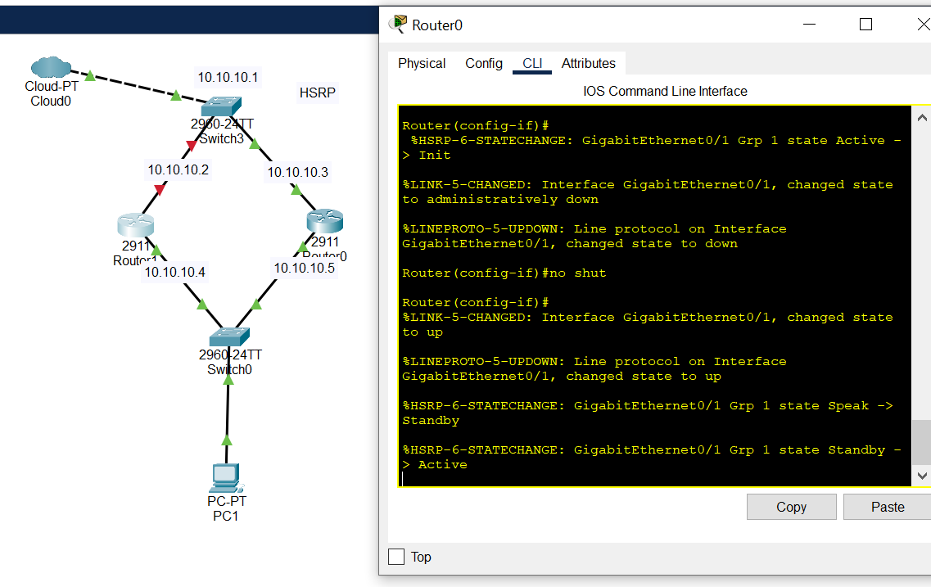
Fig 3.7: HSRP Result

CODE:

Router1:

Router>en
Router#conf t
Router(config)#ip
Router(config)#int gigabitEthernet 0/0
Router(config-if)#no shut
Router(config-if)#ip address 10.10.10.4 255.255.255.0
Router(config-if)#exit
Router(config)#
Router(config)#interface gigabitEthernet 0/1
Router(config-if)#no shut
Router(config-if)#ip address
Router(config-if)#ip address 10.10.10.2 255.255.255.0
Router(config-if)#standby 1 ip 10.10.10.1
Router(config-if)#standby 1 priority 120
Router(config-if)#
Router(config-if)#exit
Router(config)#

Router2:

Router>en
Router#conf t
Router(config)#
Router(config)#interface gigabitEthernet 0/1
Router(config-if)#no shut
Router(config-if)#
Router(config-if)#ip address 10.10.10.3 255.255.255.0
Router(config-if)#standby 1 ip 10.10.10.1
Router(config-if)#standby1 priority 105
Router(config-if)#ex
Router(config)#
Router(config)#int gig 0/0
Router(config-if)#no shut
Router(config-if)#ip address 10.10.10.5 255.255.255.0
Router(config-if)#
3.8 Switch Name Change:

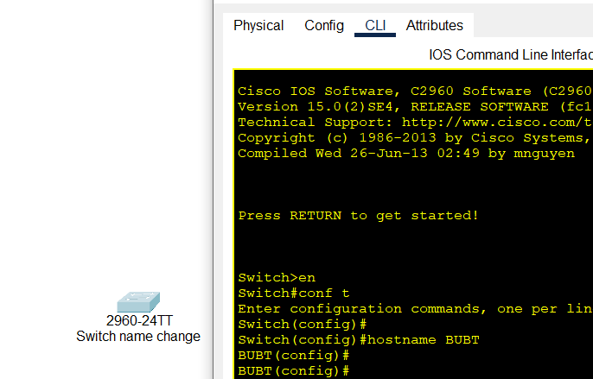

Fig 3.8:Switch name Change

CODE:

Switch>en
Switch#conf t
Enter configuration commands, one per line. End with CNTL/Z.
Switch(config)#
Switch(config)#hostname BUBT
BUBT(config)#
BUBT(config)#

CHAPTER 4
METHODOLOGY

4.1 Introduction

Methodology is a system of a particular procedure for accomplishing an objective in a particular field. A system of broad principles or rules from which specific methods or procedures may be derived to interpret or solve different problems within the scope of a particular discipline.

4.2 Methodology

There are six steps in ensuring this project achieves its objectives. Firstly, the literature reviews the networking fundamentals, especially on routing and switching processes. Based on the study, it is known that the routing and switching process is completely complex. There are several things that need to be considered in the routing process, such as; the path determination, choosing the best algorithm to be used, using the suitable routing protocol, and etc.

At the same time, the literature review on the software that has been used is also done. After learning about the software, it is known that the software only supports the Cisco router. The software also has some limitations in running the router, so it is limited to the number of routers that can be simulated, thus limiting the type of topology that can be simulated. Next process is modeling the router topology in Packet Tracer software. The main part of this project is to develop several router topologies to enhance the understanding in the routing process. In each topology, there is a router configuring process. It is necessary to make sure the topology can work well.

4.3 Packet Tracer Network Simulator

Packet Tracer or the graphical network simulator is a graphical network simulator that allows simulation of complex networks. Packet Tracer is an excellent complementary tool to real labs network for network engineers, administrators and people wanting to pass certifications such as CCNA, CCNP, etc.

4.4 Creating a Topology in Packet Tracer

Creating a topology in Packet Tracer is quite straightforward, especially for those who are already familiar with other networking software like GNS3. The layout of Packet Tracer work windows. Before start using the software, users need to provide the IOS

image by themselves to allow the use of a router. The workspace window in Packet Tracer software. It is divided into four panes by default, the leftmost pane lists the types of nodes available. Users can see the router icons for various platforms, PIX firewall, Ethernet switch, etc. The right most pane will provide a topology summary. The middle section contains two panes. The top one is the workspace window; it is the area where the user will make the topology by drag and drop the devices. The bottom one, called the console, shows how the Dynein works.

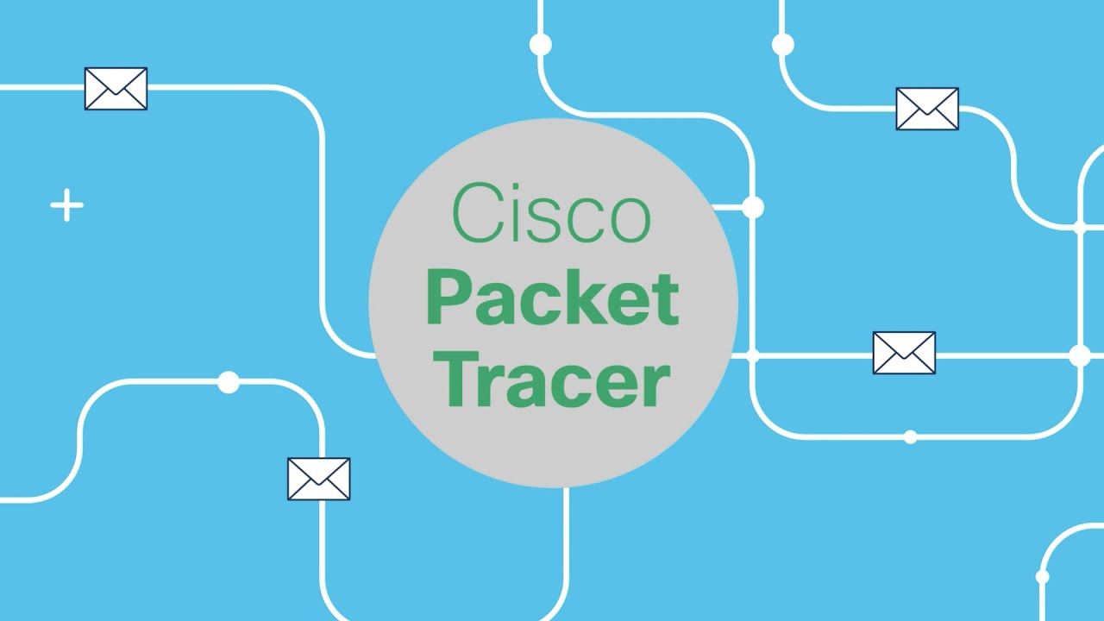

Fig 4.1: Packet Tracer Overview

CHAPTER 5
NETWORK DESIGN

5.1 Introduction

Network planning and design is an iterative process, encompassing topological design, network-synthesis, and network-realization, and is aimed at ensuring that a new telecommunications network or service meets the needs of the subscriber and operator.

5.2 Scenario of study

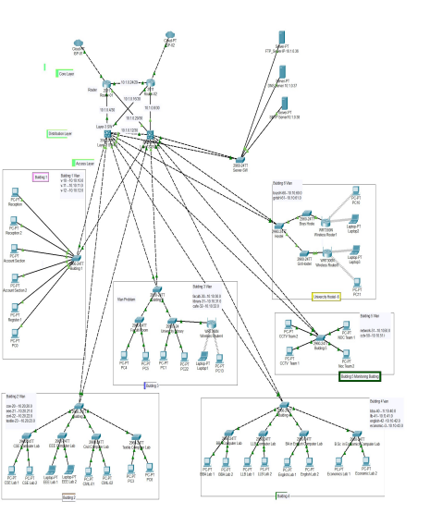
Fig 5.1: Network Design
Core Layer Configuration:

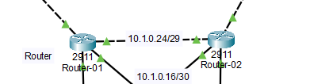
Fig 5.2: Core Layer

Code:
Router-01# Interface Configuration

interface GigabitEthernet0/0
ip address 10.1.0.25 255.255.255.248
duplex auto
speed auto
standby 0 ip 10.1.0.27
standby priority 130
!
interface GigabitEthernet0/1
ip address 10.1.0.5 255.255.255.252
duplex auto
speed auto
!
interface GigabitEthernet0/2
ip address 10.1.0.22 255.255.255.252
duplex auto
speed auto

Router-01# OSPF Configuration

router ospf 10
network 10.1.0.24 0.0.0.7 area 0
network 10.1.0.4 0.0.0.3 area 0
network 10.1.0.20 0.0.0.3 area 0
!

Router-02# Interface Configuration

interface GigabitEthernet0/0
ip address 10.1.0.26 255.255.255.248
duplex auto
speed auto
standby 0 ip 10.1.0.27
standby priority 110
!
interface GigabitEthernet0/1
ip address 10.1.0.9 255.255.255.252
duplex auto
speed auto
!
interface GigabitEthernet0/2
ip address 10.1.0.17 255.255.255.252
duplex auto
speed auto
!

Router-02# OSPF Configuration

router ospf 10
log-adjacency-change
network 10.1.0.24 0.0.0.7 area 0
network 10.1.0.16 0.0.0.3 area 0
network 10.1.0.8 0.0.0.3 area 0

Distribution Layer Configuration:

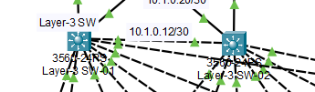
Fig 5.3: Distribution Layer

Code:
################Layer-3_SW-01#############

Layer-3_SW-01 -Hostname Configuration

hostname Layer-3_SW-01

Layer-3_SW-01 -Baner Configuration

banner login ^C

*******************************************************************************
* *
* @@@@@@@@@@@@@@@@@@@@ This system is property of @@@@@@@@@@@@
* ### BUBT Final Project ### *
* Unauthorized access or use is prohibited and may be subject to discipline, *
* civil suit or criminal prosecution. To the extent permitted by law, *
* system use may be monitored, recorded or disclosed and using the system *
* constitutes your consent to do so. You also agree to comply with procedures *
* for system use and protection of information, including but not limited to *
* proprietary information,personally identifiable information and export *
* controlled information. *
*
***************************************************************************** *
^C
!

Layer-3_SW-01 -VLAN Configuration

Layer-3_SW-01(config)#vlan 10
Layer-3_SW-01(config-vlan)#name Reception

Layer-3_SW-01(config)#vlan 11
Layer-3_SW-01(config-vlan)#name Reception

Layer-3_SW-01(config)#vlan 12
Layer-3_SW-01(config-vlan)#name Reception

Layer-3_SW-01(config)#vlan 20
Layer-3_SW-01(config-vlan)#name Reception

Layer-3_SW-01(config)#vlan 21
Layer-3_SW-01(config-vlan)#name Reception

Layer-3_SW-01(config)#vlan 22
Layer-3_SW-01(config-vlan)#name Reception

Layer-3_SW-01(config)#vlan 23
Layer-3_SW-01(config-vlan)#name Reception

Layer-3_SW-01(config)#vlan 30
Layer-3_SW-01(config-vlan)#name Reception

Layer-3_SW-01(config)#vlan 31
Layer-3_SW-01(config-vlan)#name Reception

Layer-3_SW-01(config)#vlan 32
Layer-3_SW-01(config-vlan)#name Reception

Layer-3_SW-01(config)#vlan 40
Layer-3_SW-01(config-vlan)#name Reception

Layer-3_SW-01(config)#vlan 41
Layer-3_SW-01(config-vlan)#name Reception

Layer-3_SW-01(config)#vlan 42
Layer-3_SW-01(config-vlan)#name Reception

Layer-3_SW-01(config)#vlan 43
Layer-3_SW-01(config-vlan)#name Reception

Layer-3_SW-01(config)#vlan 50
Layer-3_SW-01(config-vlan)#name Reception

Layer-3_SW-01(config)#vlan 51
Layer-3_SW-01(config-vlan)#name Reception

Layer-3_SW-01(config)#vlan 60
Layer-3_SW-01(config-vlan)#name Reception

Layer-3_SW-01(config)#vlan 61
Layer-3_SW-01(config-vlan)#name Reception

Layer-3_SW-01 - Interface Configuration

interface FastEthernet0/1
switchport trunk encapsulation dot1q
switchport mode trunk
!
interface FastEthernet0/2
no switchport
ip address 10.1.0.6 255.255.255.252
duplex auto
speed auto
!
interface FastEthernet0/3
no switchport
ip address 10.1.0.18 255.255.255.252
duplex auto
speed auto
!
interface FastEthernet0/4
switchport trunk encapsulation dot1q
switchport mode trunk
!
interface FastEthernet0/5
switchport trunk encapsulation dot1q
switchport mode trunk
!
interface FastEthernet0/6
switchport trunk encapsulation dot1q
switchport mode trunk
!
interface FastEthernet0/7
description "Connected to Serverfirm SW"
switchport trunk encapsulation dot1q
switchport mode trunk
!
interface FastEthernet0/8
switchport trunk encapsulation dot1q
switchport mode trunk
!
interface FastEthernet0/9
switchport trunk encapsulation dot1q
switchport mode trunk
!
interface FastEthernet0/10
switchport trunk encapsulation dot1q
switchport mode trunk
!

Layer-3_SW-01 - OSPF Configuration

router ospf 10
log-adjacency-changes
network 10.1.0.4 0.0.0.3 area 0
network 10.1.0.12 0.0.0.3 area 0
network 10.1.0.16 0.0.0.3 area 0
network 10.1.0.32 0.0.0.0 area 0
!

Layer-3_SW-01 - DHCP Configuration

ip dhcp pool Reception
network 10.10.10.0 255.255.255.0
default-router 10.10.10.1

ip dhcp pool Account
network 10.10.11.0 255.255.255.0
default-router 10.10.11.1

ip dhcp pool Student_Canteen
network 10.10.12.0 255.255.255.0
default-router 10.10.12.1

ip dhcp pool CSE_LAB
network 10.20.20.0 255.255.255.0
default-router 10.20.20.1

ip dhcp pool EEE_LAB
network 10.20.21.0 255.255.255.0
default-router 10.20.21.1

ip dhcp pool CIVIL_LAB
network 10.20.22.0 255.255.255.0
default-router 10.20.22.1

ip dhcp pool Textile_LAB
network 10.20.23.0 255.255.255.0
default-router 10.20.23.1

ip dhcp pool Faculti_Room
network 10.30.30.0 255.255.255.0
default-router 10.30.30.1

ip dhcp pool Library
network 10.30.31.0 255.255.255.0
default-router 10.30.31.1

ip dhcp pool BBA
network 10.40.40.0 255.255.255.0
default-router 10.40.40.1

ip dhcp pool LLB
network 10.40.41.0 255.255.255.0
default-router 10.40.41.1

ip dhcp pool English
network 10.40.42.0 255.255.255.0
default-router 10.40.42.1

ip dhcp pool Economic
network 10.40.43.0 255.255.255.0
default-router 10.40.43.1

ip dhcp pool NMS_Team
network 10.50.50.0 255.255.255.0
default-router 10.50.50.1

ip dhcp pool CCTV-Team
network 10.50.51.0 255.255.255.0
default-router 10.50.51.1

ip dhcp pool University_Hostel
network 10.60.60.0 255.255.255.0
default-router 10.60.60.1
!

Layer-3_SW-01 - HSRP Configuration

!
interface Vlan10
description Reception
mac-address 0001.974c.8c01
ip address 10.10.10.2 255.255.255.0
standby version 2
standby 10 ip 10.10.10.1
standby 10 priority 110
!
interface Vlan11
description Account
mac-address 0001.974c.8c02
ip address 10.10.11.2 255.255.255.0
standby version 2
standby 11 ip 10.10.11.1
standby 11 priority 110
!
interface Vlan12
description Student Canteen
mac-address 0001.974c.8c03
ip address 10.10.12.2 255.255.255.0
standby version 2
standby 12 ip 10.10.12.1
standby 12 priority 110
!
interface Vlan20
description CSE_LAB
mac-address 0001.974c.8c04
ip address 10.20.20.2 255.255.255.0
standby version 2
standby 20 ip 10.20.20.1
standby 20 priority 110
!
interface Vlan21
description EEE_LAB
mac-address 0001.974c.8c05
ip address 10.20.21.2 255.255.255.0
standby version 2
standby 21 ip 10.20.21.1
standby 21 priority 110
!
interface Vlan22
description Civil_LAB
mac-address 0001.974c.8c06
ip address 10.20.22.2 255.255.255.0
standby version 2
standby 22 ip 10.20.22.1
standby 22 priority 110
!
interface Vlan23
description Textile_LAB
mac-address 0001.974c.8c07
ip address 10.20.23.2 255.255.255.0
standby version 2
standby 23 ip 10.20.23.1
standby 23 priority 110
!
interface Vlan30
description Faculty
mac-address 0001.974c.8c08
ip address 10.30.30.2 255.255.255.0
standby version 2
standby 30 ip 10.30.30.1
standby 30 priority 110
!
interface Vlan31
description Library
mac-address 0001.974c.8c09
ip address 10.30.31.2 255.255.255.0
standby version 2
standby 31 ip 10.30.31.1
standby 31 priority 110
!
interface Vlan40
description BBA
mac-address 0001.974c.8c0a
ip address 10.40.40.2 255.255.255.0
standby version 2
standby 40 ip 10.40.40.1
standby 40 priority 110
!
interface Vlan41
description LLB
mac-address 0001.974c.8c0b
ip address 10.40.41.2 255.255.255.0
standby version 2
standby 41 ip 10.40.41.1
standby 41 priority 110
!
interface Vlan42
description English
mac-address 0001.974c.8c0c
ip address 10.40.42.2 255.255.255.0
standby version 2
standby 42 ip 10.40.42.1
standby 42 priority 110
!
interface Vlan43
description Economic
mac-address 0001.974c.8c0d
ip address 10.40.43.2 255.255.255.0
standby version 2
standby 43 ip 10.40.43.1
standby 43 priority 110
!
interface Vlan50
description NMS
mac-address 0001.974c.8c0e
ip address 10.50.50.2 255.255.255.0
standby version 2
standby 50 ip 10.50.50.1
standby 50 priority 110
!
interface Vlan51
description CCTV
mac-address 0001.974c.8c0f
ip address 10.50.51.2 255.255.255.0
standby version 2
standby 51 ip 10.50.51.1
standby 51 priority 110
!
interface Vlan60
description Hostel
mac-address 0001.974c.8c10
ip address 10.60.60.2 255.255.255.0
standby version 2
standby 60 ip 10.60.60.1
standby 60 priority 110
!
interface Vlan123
description Server-Network
mac-address 0001.974c.8c11
ip address 10.1.0.34 255.255.255.240
standby version 2
standby 123 ip 10.1.0.33
standby 123 priority 120
!
!
interface Vlan10
description Reception
mac-address 0001.974c.8c01
ip address 10.10.10.2 255.255.255.0
standby version 2
standby 10 ip 10.10.10.1
standby 10 priority 110
!
interface Vlan11
description Account
mac-address 0001.974c.8c02
ip address 10.10.11.2 255.255.255.0
standby version 2
standby 11 ip 10.10.11.1
standby 11 priority 110
!
interface Vlan12
description Student Canteen
mac-address 0001.974c.8c03
ip address 10.10.12.2 255.255.255.0
standby version 2
standby 12 ip 10.10.12.1
standby 12 priority 110
!
interface Vlan20
description CSE_LAB
mac-address 0001.974c.8c04
ip address 10.20.20.2 255.255.255.0
standby version 2
standby 20 ip 10.20.20.1
standby 20 priority 110
!
interface Vlan21
description EEE_LAB
mac-address 0001.974c.8c05
ip address 10.20.21.2 255.255.255.0
standby version 2
standby 21 ip 10.20.21.1
standby 21 priority 110
!
interface Vlan22
description Civil_LAB
mac-address 0001.974c.8c06
ip address 10.20.22.2 255.255.255.0
standby version 2
standby 22 ip 10.20.22.1
standby 22 priority 110
!
interface Vlan23
description Textile_LAB
mac-address 0001.974c.8c07
ip address 10.20.23.2 255.255.255.0
standby version 2
standby 23 ip 10.20.23.1
standby 23 priority 110
!
interface Vlan30
description Faculty
mac-address 0001.974c.8c08
ip address 10.30.30.2 255.255.255.0
standby version 2
standby 30 ip 10.30.30.1
standby 30 priority 110
!
interface Vlan31
description Library
mac-address 0001.974c.8c09
ip address 10.30.31.2 255.255.255.0
standby version 2
standby 31 ip 10.30.31.1
standby 31 priority 110
!
interface Vlan40
description BBA
mac-address 0001.974c.8c0a
ip address 10.40.40.2 255.255.255.0
standby version 2
standby 40 ip 10.40.40.1
standby 40 priority 110
!
interface Vlan41
description LLB
mac-address 0001.974c.8c0b
ip address 10.40.41.2 255.255.255.0
standby version 2
standby 41 ip 10.40.41.1
standby 41 priority 110
!
interface Vlan42
description English
mac-address 0001.974c.8c0c
ip address 10.40.42.2 255.255.255.0
standby version 2
standby 42 ip 10.40.42.1
standby 42 priority 110
!
interface Vlan43
description Economic
mac-address 0001.974c.8c0d
ip address 10.40.43.2 255.255.255.0
standby version 2
standby 43 ip 10.40.43.1
standby 43 priority 110
!
interface Vlan50
description NMS
mac-address 0001.974c.8c0e
ip address 10.50.50.2 255.255.255.0
standby version 2
standby 50 ip 10.50.50.1
standby 50 priority 110
!
interface Vlan51
description CCTV
mac-address 0001.974c.8c0f
ip address 10.50.51.2 255.255.255.0
standby version 2
standby 51 ip 10.50.51.1
standby 51 priority 110
!
interface Vlan60
description Hostel
mac-address 0001.974c.8c10
ip address 10.60.60.2 255.255.255.0
standby version 2
standby 60 ip 10.60.60.1
standby 60 priority 110
!
interface Vlan123
description Server-Network
mac-address 0001.974c.8c11
ip address 10.1.0.34 255.255.255.240
standby version 2
standby 123 ip 10.1.0.33
standby 123 priority 120
!

################Layer-3_SW-02#############

Layer-3_SW-02 -Hostname Configuration

hostname Layer-3_SW-02

Layer-3_SW-02 -Banner Configuration

banner login ^C

*******************************************************************************
* *
* @@@@@@@@@@@@@@@@@@@@ This system is property of @@@@@@@@@@@ *
* ### BUBT Final Project ### *
* Unauthorized access or use is prohibited and may be subject to discipline, *
* civil suit or criminal prosecution. To the extent permitted by law, *
* system use may be monitored, recorded or disclosed and using the system *
* constitutes your consent to do so. You also agree to comply with procedures *
* for system use and protection of information, including but not limited to *
* proprietary information, personally identifiable information and export *
* controlled information. *
*
***************************************************************************** *
^C
!

Layer-3_SW-02 -VLAN Configuration

Layer-3_SW-02(config)#vlan 10
Layer-3_SW-02(config-vlan)#name Reception

Layer-3_SW-01(config)#vlan 11
Layer-3_SW-01(config-vlan)#name Reception

Layer-3_SW-01(config)#vlan 12
Layer-3_SW-01(config-vlan)#name Reception

Layer-3_SW-01(config)#vlan 20
Layer-3_SW-01(config-vlan)#name Reception

Layer-3_SW-01(config)#vlan 21
Layer-3_SW-01(config-vlan)#name Reception

Layer-3_SW-01(config)#vlan 22
Layer-3_SW-01(config-vlan)#name Reception

Layer-3_SW-01(config)#vlan 23
Layer-3_SW-01(config-vlan)#name Reception

Layer-3_SW-01(config)#vlan 30
Layer-3_SW-01(config-vlan)#name Reception

Layer-3_SW-01(config)#vlan 31
Layer-3_SW-01(config-vlan)#name Reception

Layer-3_SW-01(config)#vlan 32
Layer-3_SW-01(config-vlan)#name Reception

Layer-3_SW-01(config)#vlan 40
Layer-3_SW-01(config-vlan)#name Reception

Layer-3_SW-01(config)#vlan 41
Layer-3_SW-01(config-vlan)#name Reception

Layer-3_SW-01(config)#vlan 42
Layer-3_SW-01(config-vlan)#name Reception

Layer-3_SW-01(config)#vlan 43
Layer-3_SW-01(config-vlan)#name Reception

Layer-3_SW-01(config)#vlan 50
Layer-3_SW-01(config-vlan)#name Reception

Layer-3_SW-01(config)#vlan 51
Layer-3_SW-01(config-vlan)#name Reception

Layer-3_SW-01(config)#vlan 60
Layer-3_SW-01(config-vlan)#name Reception

Layer-3_SW-01(config)#vlan 61
Layer-3_SW-01(config-vlan)#name Reception

Layer-3_SW-02 - Interface Configuration

!
interface FastEthernet0/1
switchport trunk encapsulation dot1q
switchport mode trunk
!
interface FastEthernet0/2
no switchport
ip address 10.1.0.10 255.255.255.252
duplex auto
speed auto
!
interface FastEthernet0/3
no switchport
ip address 10.1.0.21 255.255.255.252
duplex auto
speed auto
!
interface FastEthernet0/4
switchport trunk encapsulation dot1q
switchport mode trunk
!
interface FastEthernet0/5
switchport trunk encapsulation dot1q
switchport mode trunk
!
interface FastEthernet0/6
switchport trunk encapsulation dot1q
switchport mode trunk
!
interface FastEthernet0/7
switchport trunk encapsulation dot1q
switchport mode trunk
!
interface FastEthernet0/8
switchport trunk encapsulation dot1q
switchport mode trunk
!
interface FastEthernet0/9
switchport trunk encapsulation dot1q
switchport mode trunk
!
interface FastEthernet0/10
description "Connected to Server-SW"
switchport trunk encapsulation dot1q
switchport mode trunk
!

Layer-3_SW-02 - OSPF Configuration

router ospf 10
log-adjacency-changes
network 10.1.0.8 0.0.0.3 area 0
network 10.1.0.12 0.0.0.3 area 0
network 10.1.0.20 0.0.0.3 area 0
network 10.1.0.32 0.0.0.0 area 0
!

Layer-3_SW-02 - DHCP Configuration

!
ip dhcp pool Reception
network 10.10.10.0 255.255.255.0
default-router 10.10.10.1

ip dhcp pool Account
network 10.10.11.0 255.255.255.0
default-router 10.10.11.1

ip dhcp pool Student_Canteen
network 10.10.12.0 255.255.255.0
default-router 10.10.12.1

ip dhcp pool CSE_LAB
network 10.20.20.0 255.255.255.0
default-router 10.20.20.1

ip dhcp pool EEE_LAB
network 10.20.21.0 255.255.255.0
default-router 10.20.21.1

ip dhcp pool CIVIL_LAB
network 10.20.22.0 255.255.255.0
default-router 10.20.22.1

ip dhcp pool Textile_LAB
network 10.20.23.0 255.255.255.0
default-router 10.20.23.1

ip dhcp pool Faculti_Room
network 10.30.30.0 255.255.255.0
default-router 10.30.30.1

ip dhcp pool Library
network 10.30.31.0 255.255.255.0
default-router 10.30.31.1

ip dhcp pool BBA
network 10.40.40.0 255.255.255.0
default-router 10.40.40.1

ip dhcp pool LLB
network 10.40.41.0 255.255.255.0
default-router 10.40.41.1

ip dhcp pool English
network 10.40.42.0 255.255.255.0
default-router 10.40.42.1

ip dhcp pool Economic
network 10.40.43.0 255.255.255.0
default-router 10.40.43.1

ip dhcp pool NMS_Team
network 10.50.50.0 255.255.255.0
default-router 10.50.50.1

ip dhcp pool CCTV-Team
network 10.50.51.0 255.255.255.0
default-router 10.50.51.1

ip dhcp pool University_Hostel
network 10.60.60.0 255.255.255.0
default-router 10.60.60.1
!

Layer-3_SW-02 - HSRP Configuration

!
interface Vlan10
description Reception
mac-address 00e0.f7dc.2401
ip address 10.10.10.3 255.255.255.0
standby version 2
standby 10 ip 10.10.10.1
!
interface Vlan11
description Account
mac-address 00e0.f7dc.2402
ip address 10.10.11.3 255.255.255.0
standby version 2
standby 11 ip 10.10.11.1
!
interface Vlan12
description Account
mac-address 00e0.f7dc.2403
ip address 10.10.12.3 255.255.255.0
standby version 2
standby 12 ip 10.10.12.1
!
interface Vlan20
description CSE_LAB
mac-address 00e0.f7dc.2404
ip address 10.20.20.3 255.255.255.0
standby version 2
standby 20 ip 10.20.20.1
!
interface Vlan21
description EEE_LAB
mac-address 00e0.f7dc.2405
ip address 10.20.21.3 255.255.255.0
standby version 2
standby 21 ip 10.20.21.1
!
interface Vlan22
description Civil_LAB
mac-address 00e0.f7dc.2406
ip address 10.20.22.3 255.255.255.0
standby version 2
standby 22 ip 10.20.22.1
!
interface Vlan23
description Textile_LAB
mac-address 00e0.f7dc.2407
ip address 10.20.23.3 255.255.255.0
standby version 2
standby 23 ip 10.20.23.1
!
interface Vlan30
description Faculty
mac-address 00e0.f7dc.2408
ip address 10.30.30.3 255.255.255.0
standby version 2
standby 30 ip 10.30.30.1
!
interface Vlan31
description Library
mac-address 00e0.f7dc.2409
ip address 10.30.31.3 255.255.255.0
standby version 2
standby 31 ip 10.30.31.1
!
interface Vlan40
description BBA
mac-address 00e0.f7dc.240a
ip address 10.40.40.3 255.255.255.0
standby version 2
standby 40 ip 10.40.40.1
!
interface Vlan41
description LLB
mac-address 00e0.f7dc.240b
ip address 10.40.41.3 255.255.255.0
standby version 2
standby 41 ip 10.40.41.1
!
interface Vlan42
description English
mac-address 00e0.f7dc.240c
ip address 10.40.42.3 255.255.255.0
standby version 2
standby 42 ip 10.40.42.1
!
interface Vlan43
description Economic
mac-address 00e0.f7dc.240d
ip address 10.40.43.3 255.255.255.0
standby version 2
standby 43 ip 10.40.43.1
!
interface Vlan50
description NMS
mac-address 00e0.f7dc.240e
ip address 10.50.50.3 255.255.255.0
standby version 2
standby 50 ip 10.50.50.1
!
interface Vlan51
description CCTV
mac-address 00e0.f7dc.240f
ip address 10.50.51.3 255.255.255.0
standby version 2
standby 51 ip 10.50.51.1
!
interface Vlan60
description Hostel
mac-address 00e0.f7dc.2410
ip address 10.60.60.3 255.255.255.0
standby version 2
standby 60 ip 10.60.60.1
!
interface Vlan123
description Server-Network
mac-address 00e0.f7dc.2411
ip address 10.1.0.35 255.255.255.240
standby version 2
standby 123 ip 10.1.0.33
standby 123 priority 120
!
interface Vlan303
mac-address 00e0.f7dc.2412
ip address 10.1.0.13 255.255.255.252
!
Building 1 Configuration:

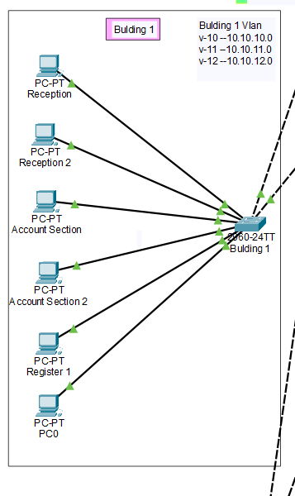
Fig 5.4: Building 1 Configuration

Code:
##############Building-01_SW-01(config)# Configuration##########

Building-01_SW-01# Hostname Configuration

Building-01_SW-01(config)#hostname Building01_SW-01

Building-01_SW-01# Vlan Configuration

Building-01_SW-01(config)#vlan 10
Building-01_SW-01(config-vlan)#name reception

Building-01_SW-01(config)#vlan 11
Building-01_SW-01(config-vlan)#name account

Building-01_SW-01(config)#vlan 12
Building-01_SW-01(config-vlan)#name register

Building-01_SW-01# Interface Configuration

interface FastEthernet0/1
switchport mode trunk
!
interface FastEthernet0/2
switchport mode trunk
!
interface FastEthernet0/3
switchport access vlan 10
switchport mode access
!
interface FastEthernet0/4
switchport access vlan 10
switchport mode access
!
interface FastEthernet0/5
switchport access vlan 11
switchport mode access
!
interface FastEthernet0/6
switchport access vlan 11
switchport mode access
!
interface FastEthernet0/7
switchport access vlan 12
switchport mode access
!
interface FastEthernet0/8
switchport access vlan 12
switchport mode access
!

Building 2 Configuration:

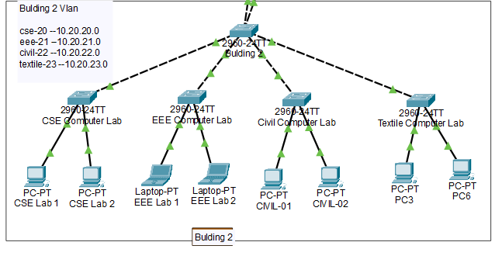
Fig 5.5: Building 2 Configuration
Code:
##############Building-02_SW-02(config)# Configuration##########

Building-02_SW-02# Hostname Configuration

Building-02_SW-02(config)#hostname Building02_SW-02

Building-02_SW-02# Vlan Configuration

Building-02_SW-02(config)#vlan 20
Building-02_SW-02(config-vlan)#name cse

Building-02_SW-02(config)#vlan 21
Building-02_SW-02(config-vlan)#name eee

Building-02_SW-02(config)#vlan 22
Building-02_SW-02(config-vlan)#name civil

Building-02_SW-02(config)#vlan 23
Building-02_SW-02(config-vlan)#name textile

Building-02_SW-02# Interface Configuration

interface FastEthernet0/1
switchport mode trunk
!
interface FastEthernet0/2
switchport mode trunk
!
interface FastEthernet0/4
switchport access vlan 20
switchport mode access
!
interface FastEthernet0/5
switchport access vlan 20
switchport mode access
!
interface FastEthernet0/6
switchport access vlan 21
switchport mode access
!
interface FastEthernet0/7
switchport access vlan 21
switchport mode access
!
interface FastEthernet0/8
switchport access vlan 22
switchport mode access
!
interface FastEthernet0/9
switchport access vlan 23
switchport mode access
!
interface FastEthernet0/10
switchport access vlan 23
switchport mode access
!

Building 3 Configuration:

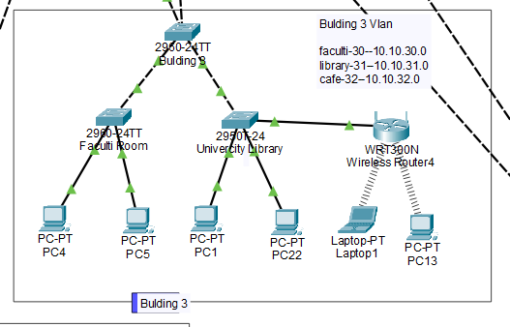
Fig 5.6: Building 3 Configuration

Code:
##############Building-03_SW-023(config)# Configuration##########

Building-03_SW-03# Hostname Configuration

Building-03_SW-03(config)#hostname Building03_SW-03

Building-03_SW-03# Vlan Configuration

Building-03_SW-03(config)#vlan 30 faculty
Building-03_SW-03(config-vlan)#name faculty

Building-03_SW-03(config)#vlan 31
Building-03_SW-03(config-vlan)#name library

Building-03_SW-03(config)#vlan 32
Building-03_SW-03(config-vlan)#name cafe

Building-03_SW-03# Interface Configuration

interface FastEthernet0/1
switchport mode trunk
!
interface FastEthernet0/2
switchport mode trunk
!
interface FastEthernet0/3
switchport access vlan 30
switchport mode access
!
interface FastEthernet0/4
switchport access vlan 30
switchport mode access
!
interface FastEthernet0/5
switchport access vlan 31
switchport mode access
!
!
interface FastEthernet0/6
switchport access vlan 31
switchport mode access
!
!
interface FastEthernet0/6
switchport access vlan 32
switchport mode access
!
!
interface FastEthernet0/7
switchport access vlan 32
switchport mode access
!

Building 4 Configuration:

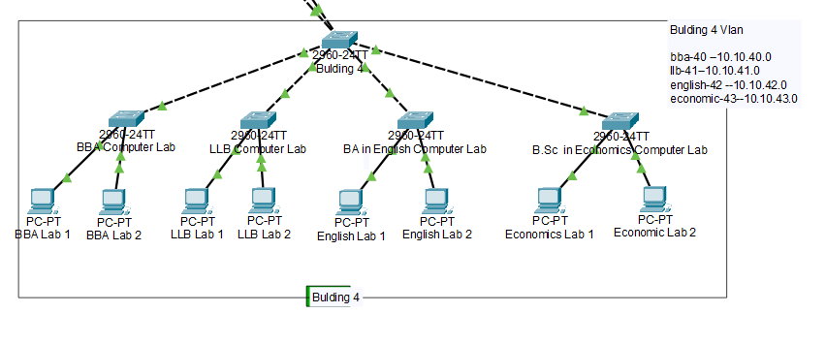
Fig 5.7: Building 4 Configuration

Code:
##############Building-04_SW-04(config)# Configuration##########

# Hostname Configuration

Building-04_SW-04(config)#hostname Building04_SW-04

# Vlan Configuration

Building-04_SW-04(config)#vlan 40 bba

Building-04_SW-04(config)#vlan 41
Building-04_SW-04(config-vlan)#name llb

Building-04_SW-04(config)#vlan 42
Building-04_SW-04(config-vlan)#name english

Building-04_SW-04(config)#vlan 43
Building-04_SW-04(config-vlan)#name economic

# Interface Configuration

interface FastEthernet0/1
switchport mode trunk
!
interface FastEthernet0/2
switchport mode trunk
!
interface FastEthernet0/3
switchport access vlan 40
switchport mode access
!
interface FastEthernet0/4
switchport access vlan 40
switchport mode access
!
interface FastEthernet0/5
switchport access vlan 41
switchport mode access
!
interface FastEthernet0/6
switchport access vlan 41
switchport mode access
!
interface FastEthernet0/7
switchport access vlan 42
switchport mode access
!
interface FastEthernet0/8
switchport access vlan 42
switchport mode access
!
interface FastEthernet0/9
switchport access vlan 43
switchport mode access
!
interface FastEthernet0/10
switchport access vlan 43
switchport mode access
!

Building 5 Configuration:

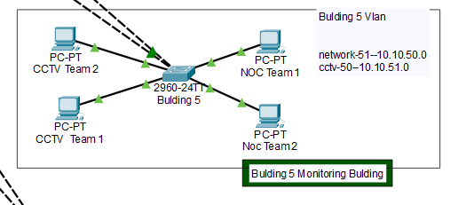
Fig 5.8: Building 5 Configuration

Code:
##############Building-05_SW-05(config)# Configuration##########

Building-05_SW-05# Hostname Configuration

Building-05_SW-05(config)#hostname Building05_SW-5

Building-05_SW-05# Vlan Configuration

Building-05_SW-05(config)#vlan 50
Building-05_SW-05(config-vlan)#name cctv

Building-05_SW-05(config)#vlan 51
Building-05_SW-05(config-vlan)#name network

Building-05_SW-05# Interface Configuration

interface FastEthernet0/1
switchport mode trunk
!
interface FastEthernet0/2
switchport mode trunk
!
interface FastEthernet0/3
switchport access vlan 50
switchport mode access
!
interface FastEthernet0/4
switchport access vlan 50
switchport mode access
!
interface FastEthernet0/5
switchport access vlan 51
switchport mode access
!
interface FastEthernet0/6
switchport access vlan 51
switchport mode access
!

Building 6 Configuration:

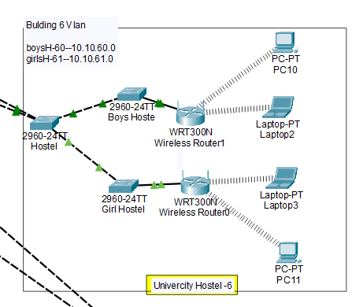
Fig 5.9: Building 6 Configuration

Code:
##############Building-06_SW-06(config)# Configuration##########

Building-06_SW-06# Hostname Configuration

Building-06_SW-06(config)#hostname Building06_SW-6

Building-06_SW-06# Vlan Configuration

Building-06_SW-06(config)#vlan 60
Building-06_SW-06(config-vlan)#name boysh

Building-06_SW-06(config)#vlan 61
Building-06_SW-06(config-vlan)#name girlsh

Building-06_SW-06# Interface Configuration

interface FastEthernet0/1
switchport mode trunk
!
interface FastEthernet0/2
switchport mode trunk
!
interface FastEthernet0/3
switchport access vlan 60
switchport mode access
!
interface FastEthernet0/4
switchport access vlan 60
switchport mode access
!
interface FastEthernet0/5
switchport access vlan 61
switchport mode access
!
interface FastEthernet0/6
switchport access vlan 61
switchport mode access
!
CHAPTER 6
CONCLUSION

6.1 Introduction

This chapter will consist of the conclusion of the project as well as the recommendation of the future project. The future project suggestion hopefully can improve the quality of the project.

6.2 Conclusion

Routing and switching in networking is very important. This knowledge is also important for the telecommunication engineer, because it is relevant and connected to the telecommunication subject. But, in reality, the networking subject is lacking in the telecommunication course. That is why there must be some other way to learn.

The purpose of this project is to enhance the understanding of networking, especially in routing and switching by developing small router network topology and performing simulation.

Network simulation is familiarly used, either in academic or the industry. The advantage of the project is, it is cost saving, especially for students and academics that have limited budgets. Because the real network simulation will be very expensive due to the expensive price of the devices.

The outcomes of this project are successful: used default routing protocol, manual Ip for every pc, also used summarization to control the traffic.

This project presented the routing network that has developed and performed the simulation through the is to enhance the understanding of the students in the first place, the envelopment and analysis of simple network topology is considered as sufficient.

Above all, we have shown how the exact network system might be usable within a very short time for which data would be reached safely from sender to receiver. And it is very expectable to all clients. In this respect, we used various types of protocol. Such as: RIP, OSPF, EIGRP. And to make the great network system easier we completed the network system using DHCP.

6.3 Recommendation

Since the scope of the study for this project can still be much explored in the future, there are some suggestions that can be followed:

- Developing the lab topology using another protocol, such as; RIP, OSPF, EIGRP It may offer a large number of hosts.
- It may offer for various branches across the country.
- It may offer to reduce packet losses.
- It may offer to reduce the link budget.

BIBLIOGRAPHY

1. Cisco Packet Tracer Documentation
http://www.cisco.com/c/en/us/td/docs/security/asdm/6_1/user/guide/usergd.pdf

2. Cisco NetAcad – Getting Started with Packet Tracer Courses
https://www.netacad.com/c/portal/saml/sso?entityId=http://373583482.neta
cad.com/saml2&RelayState=/courses/394209
https://www.netacad.com/c/portal/saml/sso?entityId=http://373583482.neta
cad.com/saml2&RelayState=/courses/378346

3. Data Communications and Network, 5th Edition – Forouzan
http://highered.mcgraw-hill.com/sites/0073376221

4. TCP/IP Protocol Suite, 4th Edition – Forouzan
http://highered.mcgraw-hill.com/sites/0073376043

5. Cryptography and Network Security – Forouzan
http://highered.mheducation.com/sites/0072870222

6. Computer Networking, 5th Edition – Tanenbaum
https://www.flipkart.com/computer-networks-5th/p/itmdkzrvw2xcanw

